When doing anything on the site on the same page,
Do not open new window,
Use popup screen or
Use Angular Js to do it without loading the page again.
We need to have smooth browsing by clicking a link, result should show without reloading.
Hovering over an object, we should see result on the same page immediately.
We want to see counter update to show immediately without refreshing on Travfeed or wall pages

QA We need to create multiple account and test between them friend request, adding comment and see how the privacy work. Additionally we need to test multiple account and see how changing different field entries maintain it self.

Notice, we when edit a post the popup window as shown below to include the tool Box and then allow member to edit the text and save the post with new privacy setting. Also Save icon rather than the Edit icon. X on the photo to remove it and + to add new photo. We do not need to show the user name nor the photo nore the time of the old post

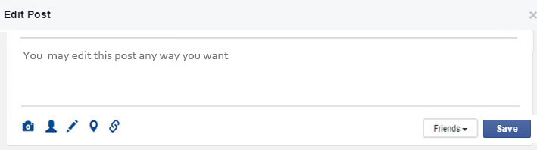

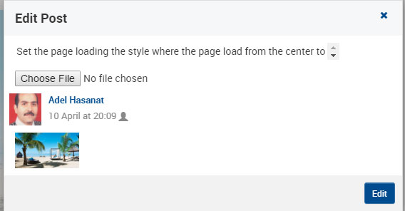

When hovering over the header photo for the wall, it should allow the user to change it
Also, when hovering over the user photo, it should ask him to change it.

- Please make the space between any comment 15 pixals, As now it show the first three correct but any additional will show only 7 pixals spacing
- Non owner should be able to hide comment not delete it
- Post owner can del any comment but can not edit other comment

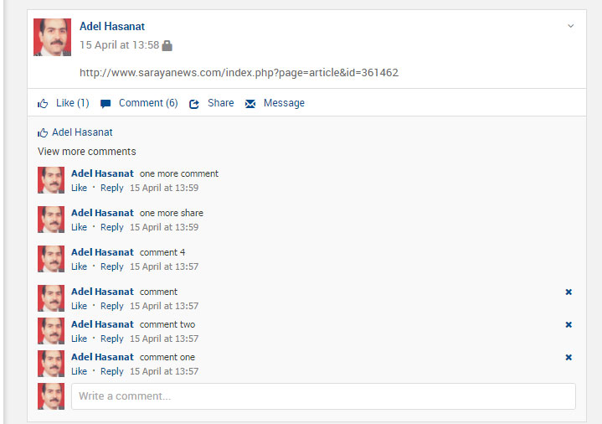

2 | Mute friend functionalities, where to show mute friend button? When you right click on that friend,  we can have an item to mute all notifications from that friend. See FB
3 | User can report abuse for any unknown users ? Also right click on that user, an item should show to report that user  with a comment box to why he is abusing

Please look into the way the logo blue bar icon for travfeed look when enlarge the screen to 150 or 175%. As of now it shows as below. We need to move the search icon maybe in the 2nd row.

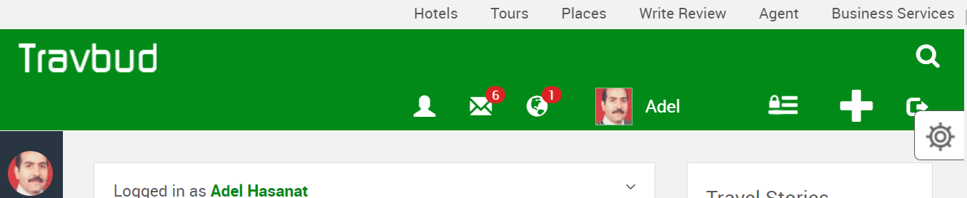
Top of Form

Under the Account setting
Modify the following

Basic information setting
When entering we need to ask for old password to prevent abuse.
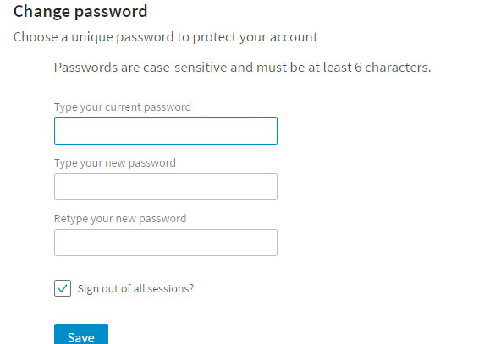

Move Current city under the city and co and Mobilr
City, should allow for auto selection which will include state and county which we can extract the state and country to store in the country field , Mobil country code is set after we select the country,

Birth date, modify the menu as on home page

Language, allow selection for most language and use normal cap and allow user to add their own and store and the new value the database.

Education, interest and occupation, allow for auto select. It shows no items but more importantly to store new added items, the system did not save my entry. No cap
When a use edit his setting for language, Education, interest and occupation his slected and stored value should show in the box.

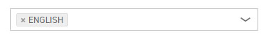
Also include count of people on the site that has certain degree or interested traveling or cooking or speaks English…

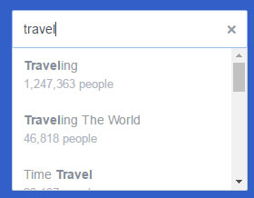

Photo
For the Photo section, please follow the given earlier instruction.
As shown below in the signup screen

Under the security section
For the security question use instead of the phone question use email on file, also, What city you born?
The current questions do not save their values.
Remove pair ads list
Remove tag Review
Dashboard View Permission it should show privacy setting rather on/off
Under the Blocking lists
Remove restricted people, the list item

Under the Privacy setting
Who can send friend request, should allow for Public and Friend of Friend and take out Friends because they are already are friends.
Dashboard View Permission
Can search engine look my dashbroad up? Show the current setting or use the animation
Add this item Who should be to see my friend list

Also add Anonymously browse other people's profiles (for VIP only)

Notifications
Play a sound when new notification is received Off
Play a sound when a message is received Off
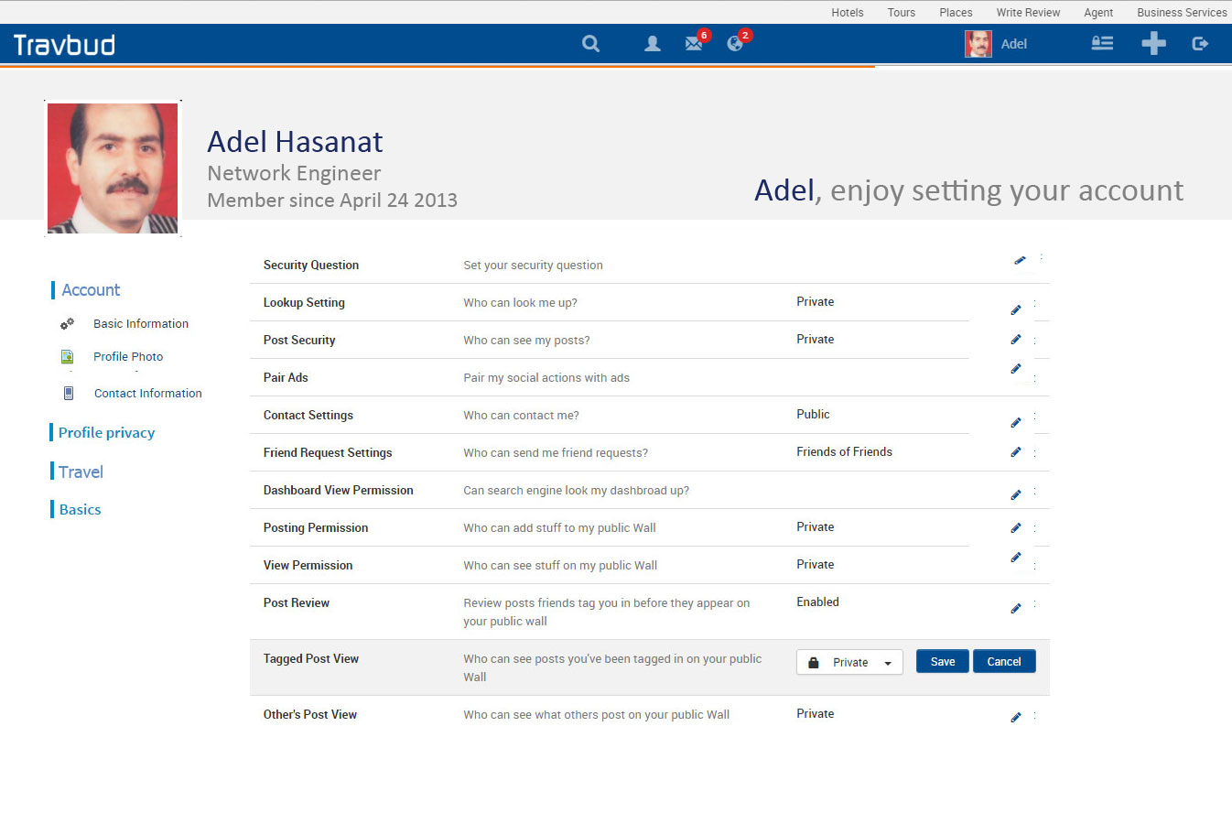

Please keep the edit pen but please revert to the Save and Cancel rather than the check and X for saving the changes.

Account: Basic Information, Profile photo, Communication, Groups
Profile Privacy: Security Setting, Notifications, Blocking
Travel: HangOut, Hire A guide, Local Host, Travel Plan
Basics: Close Account,

Please the following icon style for on/off 

Please review the slide below at 200% the ( Mobil view) where the side menu need to show correctly to hide the text that partially showing and allow me to expand it on the Mobil. Also notice the friend request screen output shortcut.

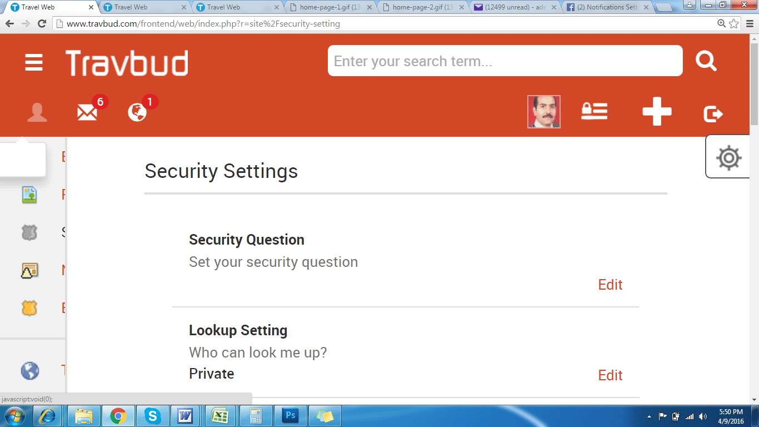

Please review the side below and fix the permission setting output at 150% and 200% where we can just move to the next line similar to the slide above. Also notice the friend request screen output shortcut. Additionally make these permission font to be gray not black as is now for all screen sizes

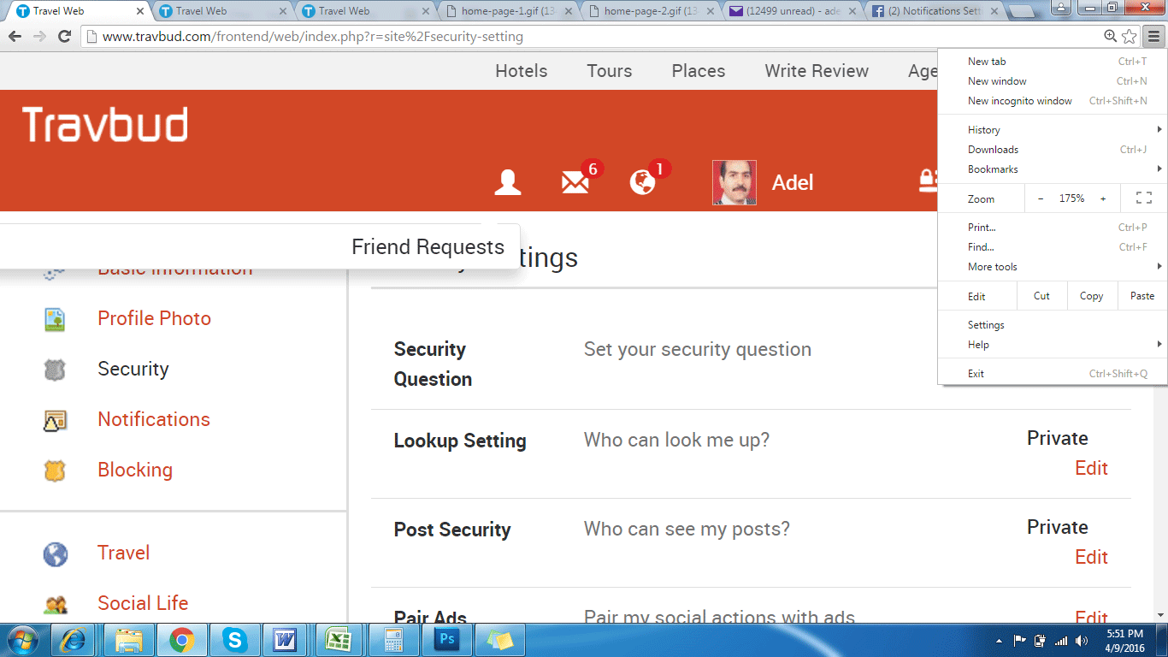

Password Reset
Please make changes to include the gray envelope rather than the blue envelope

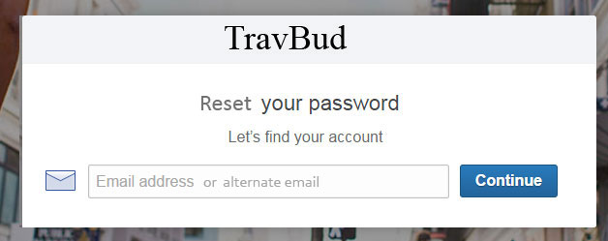

Please compared the email subject and title

When clicking on Check Email, does not work, please check
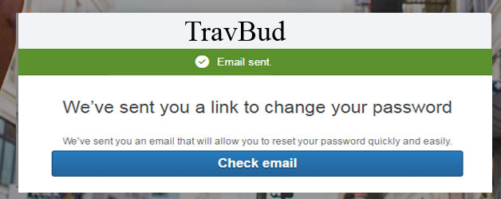

When the user click on the link, they should get a password screen similar to the screen below to add there new password and confirm it.

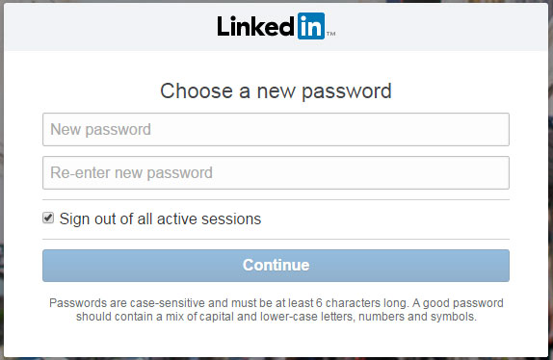

For the progress timer use thinner line like around one pixel high, also use track for it to isolted from the logo bar as shown below under the blue bar on each page, check twoo.com or youtube.com they have something similar.

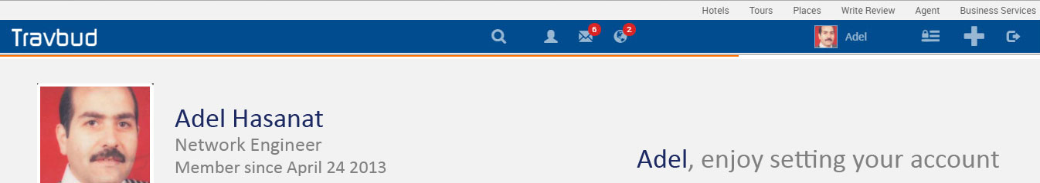

When loading an image in the posting Tool Box please use the following method as shown in the couple images while the Post icon is dim out until the image is completely loaded then the Post icon is available for the user to click on it and post the image. it looks good. Please allow for more than one image addition in any post

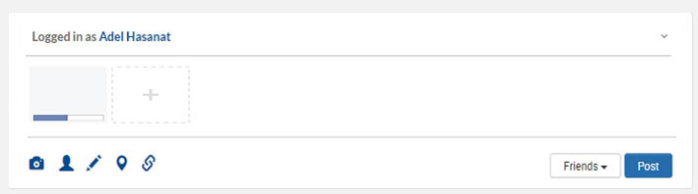

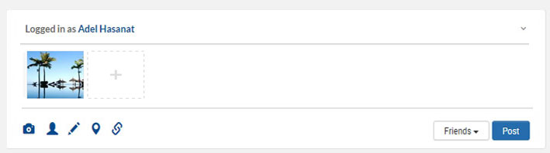

Notifications Alert Box, should show item as listed below. The Notifications should on line or two only in gray background separated with gray thin line

- Notifications when someone like or share or comments or message on member post or photo...
- All notifications about activity that involves my groups.
- Notifications when people who aren't your friends start following you and share or comment on your public posts.
- Notify me when get a friend request or confirm friendship.
- When I get eCard or postcard or eGift.
- When member invite me for a meeting.
- Notify me when a friend ask a question or responded to a question.
- When my credits is near tipping point or tipped up.

Test for this with other user: Hide Post menu item is no longer showing under the post menu, please add it back and check it to work after you hide a post and then refresh the page to see if it is still hidden.

Allow the user to Pin any image in the travfeed posts when hovering over it to his gallery on the wall

Please remove the reply on reply comment since we are allowing one reply.
Please allow user to add photo to a comment

When sharing a post allow for the following as shown in the image below

- Share and cancel icons
- Share privacy icon
- Share on your wall
- Share on friend wall
- Share on group wall
- Allow the user to add new location or friends
- Allow the user to add comment
- Show the image on the shared post
- Remove the user name and photo as now done in the post
- Notice the size of the image
- 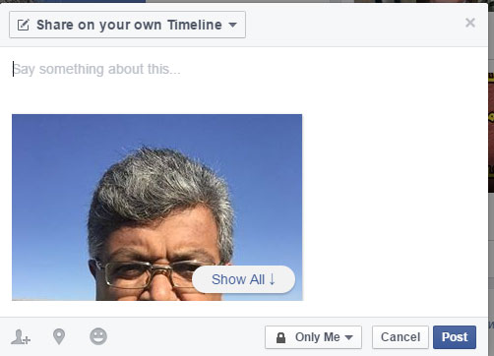

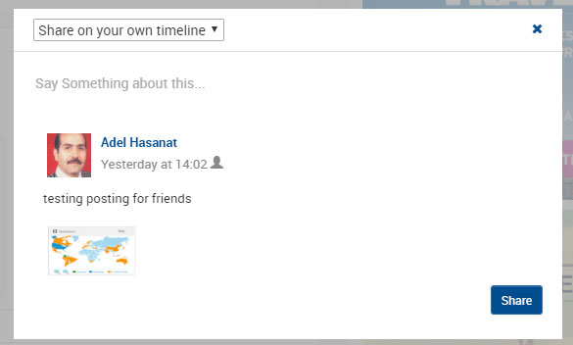

Please Note the friend list column the last column using gray color for background

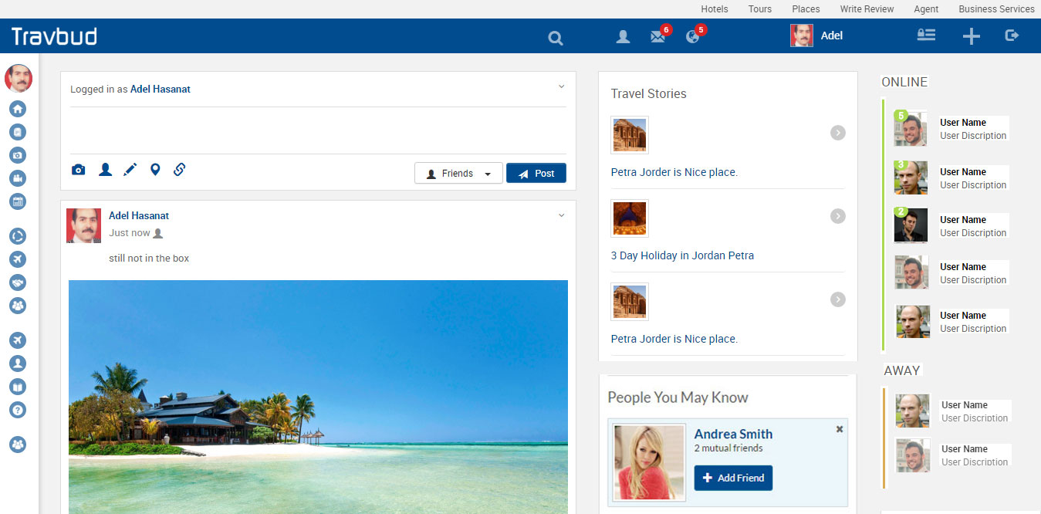

Please check on the home page as I checked the twoo.com
- The home page image is 1024x685 pixels and the image size is 153k
- Main importantly the center of the image is constant and do not move around during bootstrap sizing.
- At the default screen resolution 1366 x768,
- Make sure the space between boxes is 20 pixels for both the signin and signup
- Replace the phrase “Not a member yet, Signup here” by “Not a user, Signup here”
- When the page load, the email and password box bounce before they settle.

Set the page loading the style where the page load from the center to side for both the page and the travfeed and other pages for the whole page from.

Login testing
When I entered invalid email address for the sign in, it did not inform me of that.
When I enter a valid email by selecting from the dropdown list , still keep the red x.

When entering mismatched password on the signup screen, it show the red x without informing me of the problem neither if I entered less than four characters. It has to tell me if I have mismatched or less than characters four along with the red x.

On the birthday calendar, first time clicking on the year and the month calendar for the birthdate, it does not allow to scroll to the year or the month that I want. If I close and try again then it shows the scroller.

Please make the field box width 300 pixels and height 40 pixels and height between each flied box 20 pixels
For the facebook connect box make it the same size as twoo.com

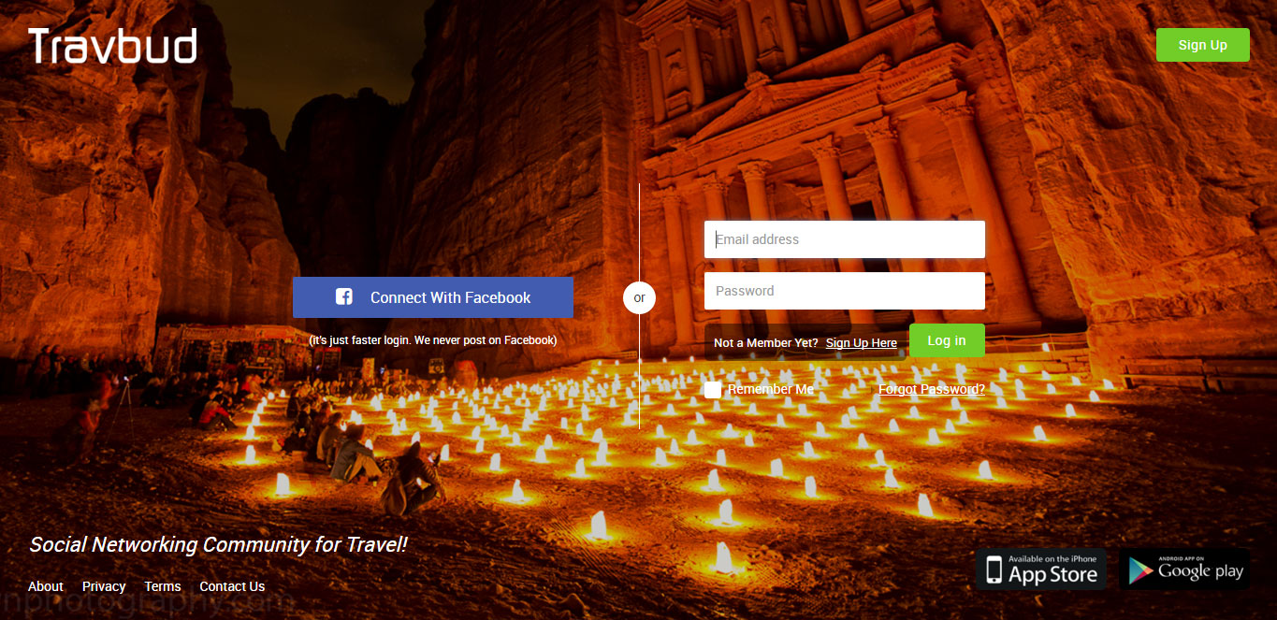

Please Note to have the field Name is gray bold, we need to use darker color than the field text but we need to use the same color throughout the website to maintain consistency.
Notice the gray shade around the fields box.
The green check and X validation is happing
The new birthdate calendar still not working

At the profile, use Create Account icon when the member is done fill the page rather than the Verify icon you are using now.
Please the pattern that I have below
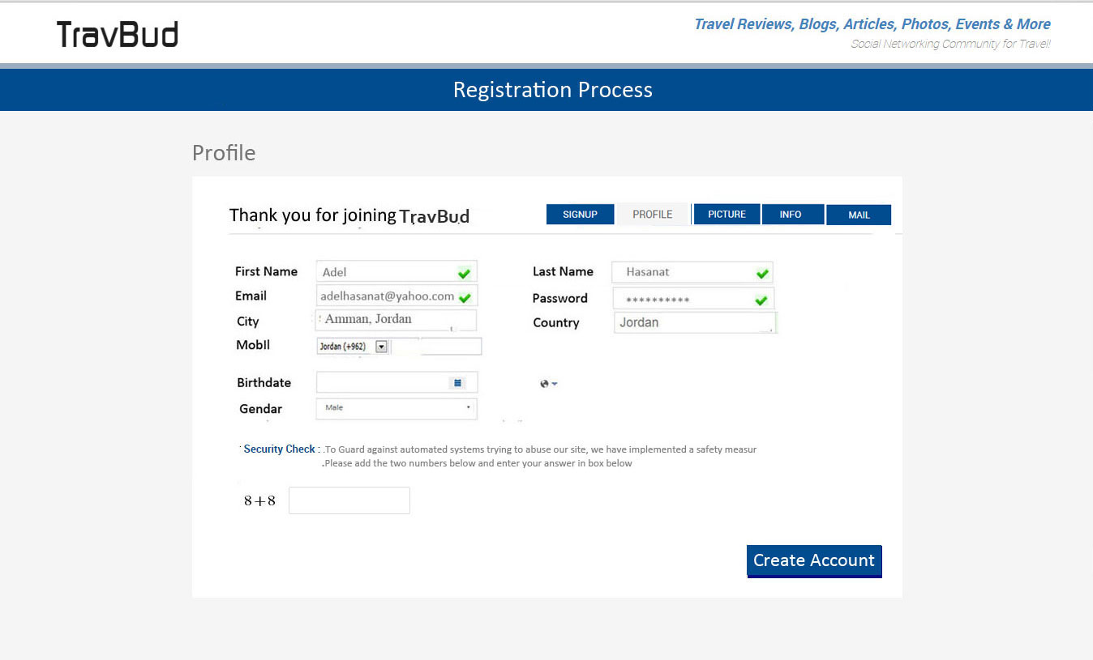

Please don use cap for the words in selecation menus
We need to use selection as much as possible to allow for more easy way to fill the box
For example education, we may list the conmen degrees and high school listing for the user to choose from
For Occupations also we may list job allowing the member to choose from
For the languages also we can do a list
For interest we have to do check box kind of setup that allows the member to choose more that one item.
Please follow the design shown below for the hosting part

Language, allow selection for most language and use normal cap and allow user to add their own and store and the new value the database.

Education, interest and occupation, allow for auto select. It shows no items but more importantly to store new added items, the system did not save my entry. No cap
When a use edit his setting for language, Education, interest and occupation his slected and stored value should show in the box.

Also include count of people on the site that has certain degree or interested traveling or cooking or speaks English…

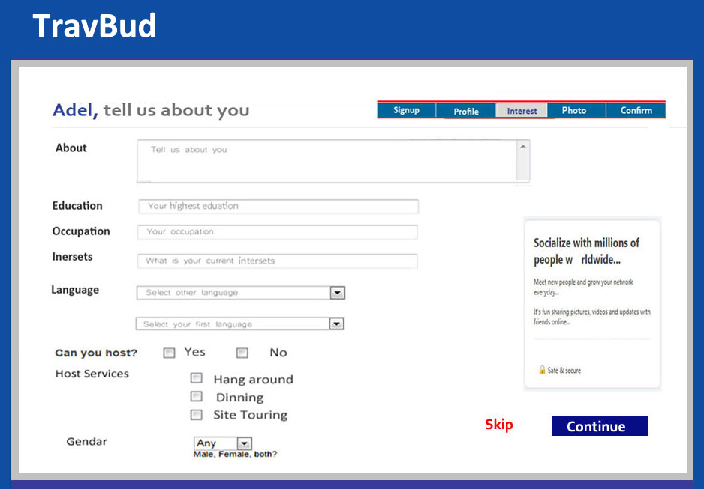

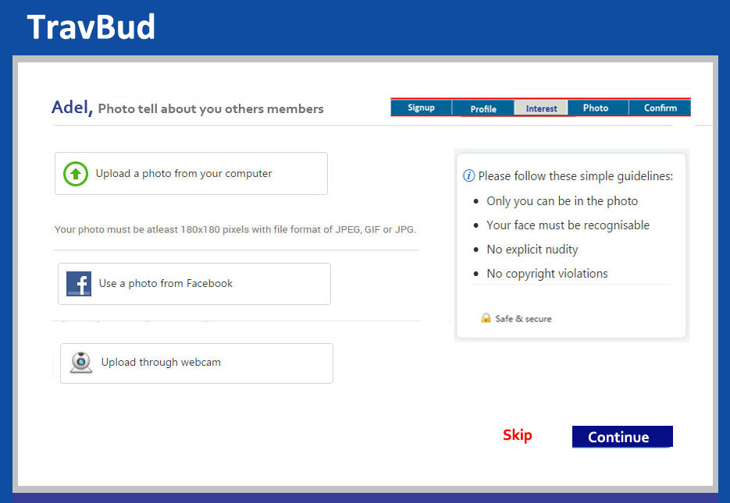

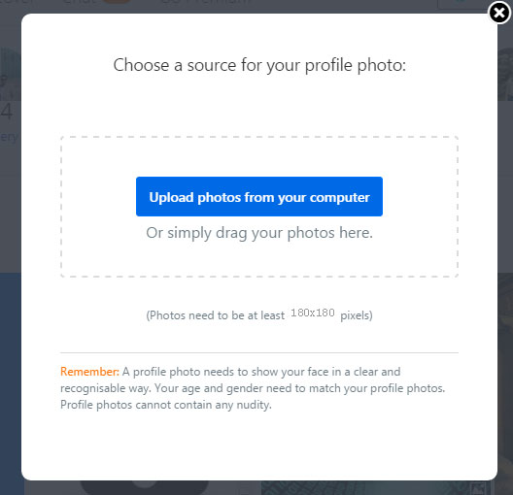

Please note the look of the photo, gallery, post, saved and wall Graphic Design look you may check Wayn.com
Please use the gray shadow level as shown in the image
Please use more bold and bigger font for the photo, friend …. As shown in the image
Please bay attention to divide the 3 columns by the gray shadow evenly Also the three columns will show the data column better in the Mobil

Please use the following tabs look as shown below with lighter gray color.

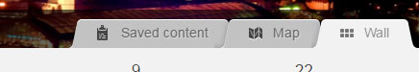

Check the about section to be similar to the following allow member to edit each of the stuff below

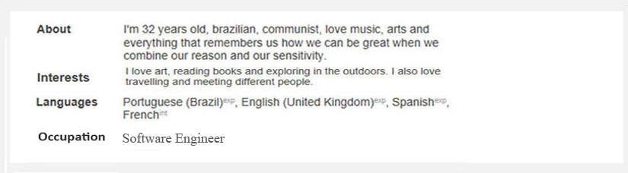

Please keep word Photo only rather “Gallery Photo” , fron the “Your Friend Activities” phrase on the Wall to make room on the Mobil

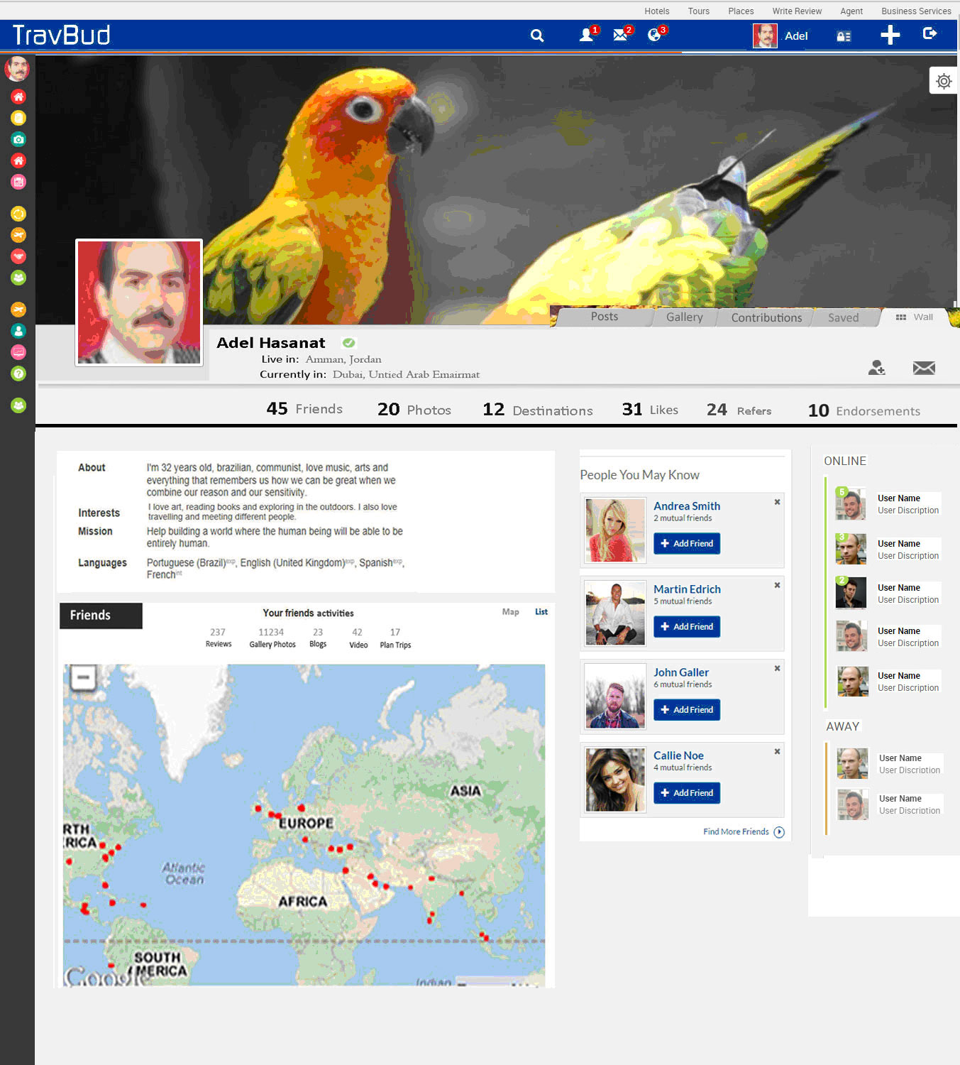

Please Notice that the Navigation on the left that some text at 150% and 175% is showing. In addition, we need a way to allow user to scroll down at this screen size. need an arrow to point down at the screen size that allow a user to click on it to allow user to scroll down

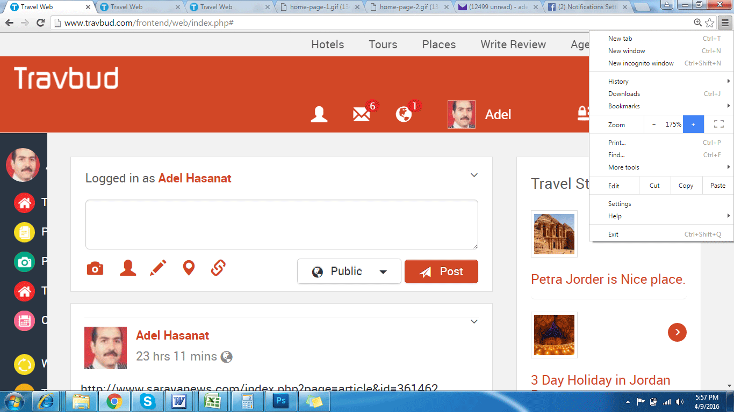

Please look at FB when loading a link, as when we add a link to Tool Box post, it load the link first with an image and some text while the post icon is dimmed. Once the link is loaded then we can post the image and the text as shown below.

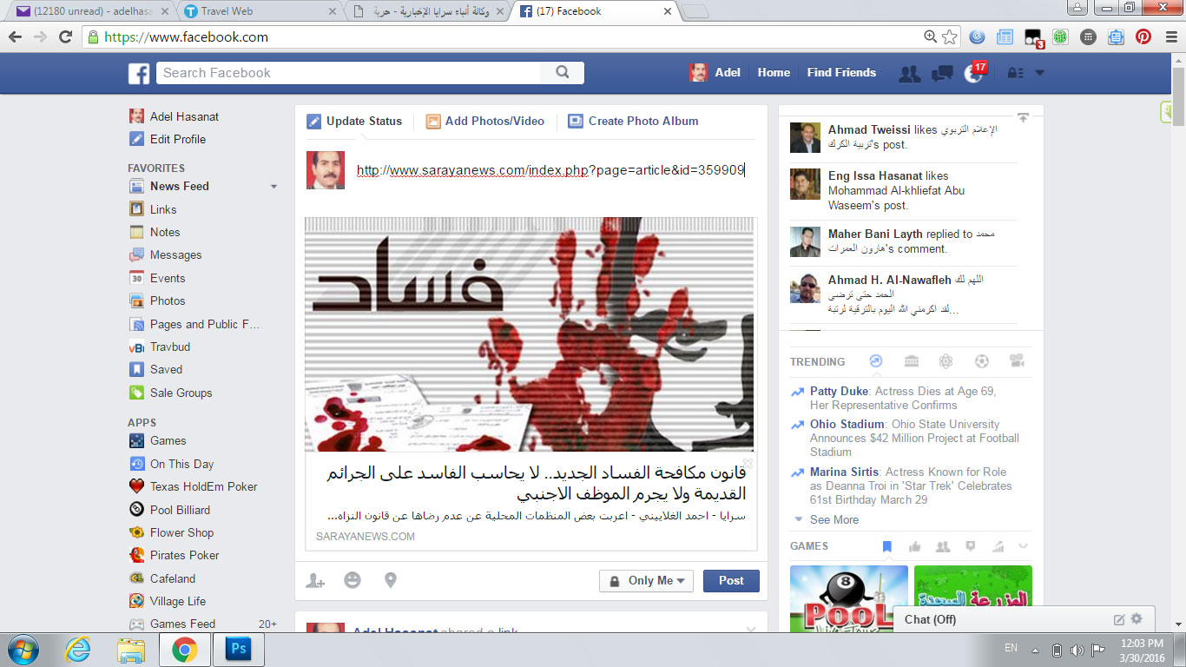

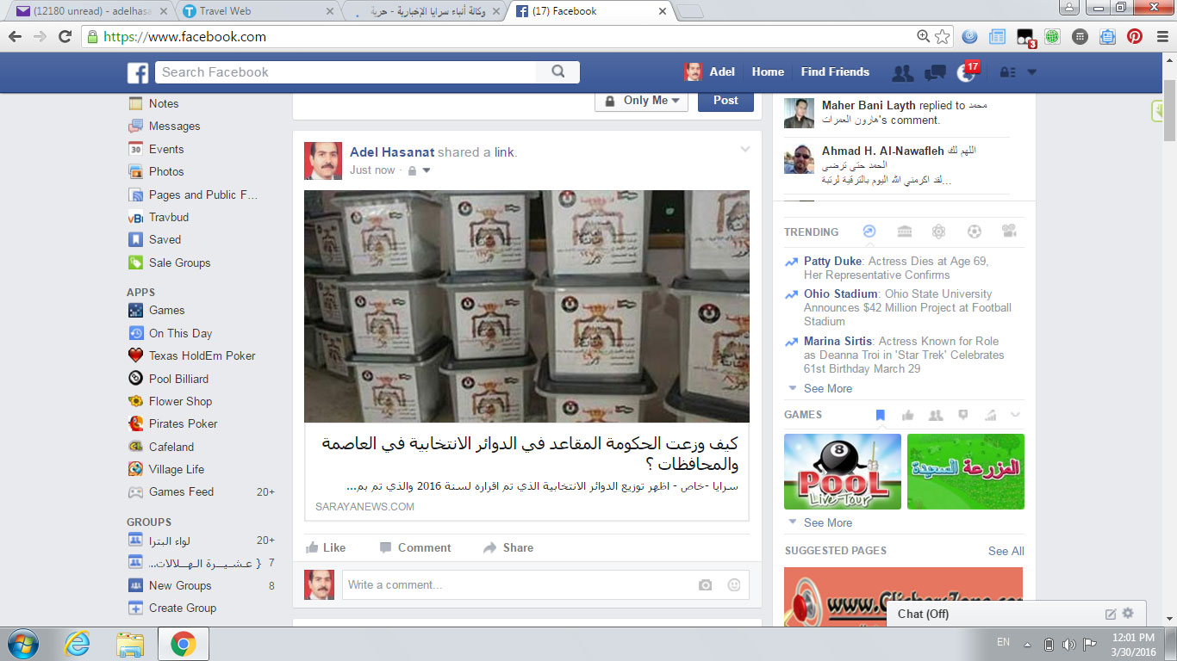

This the Galley output please look at Wayn.com how they handle these photo

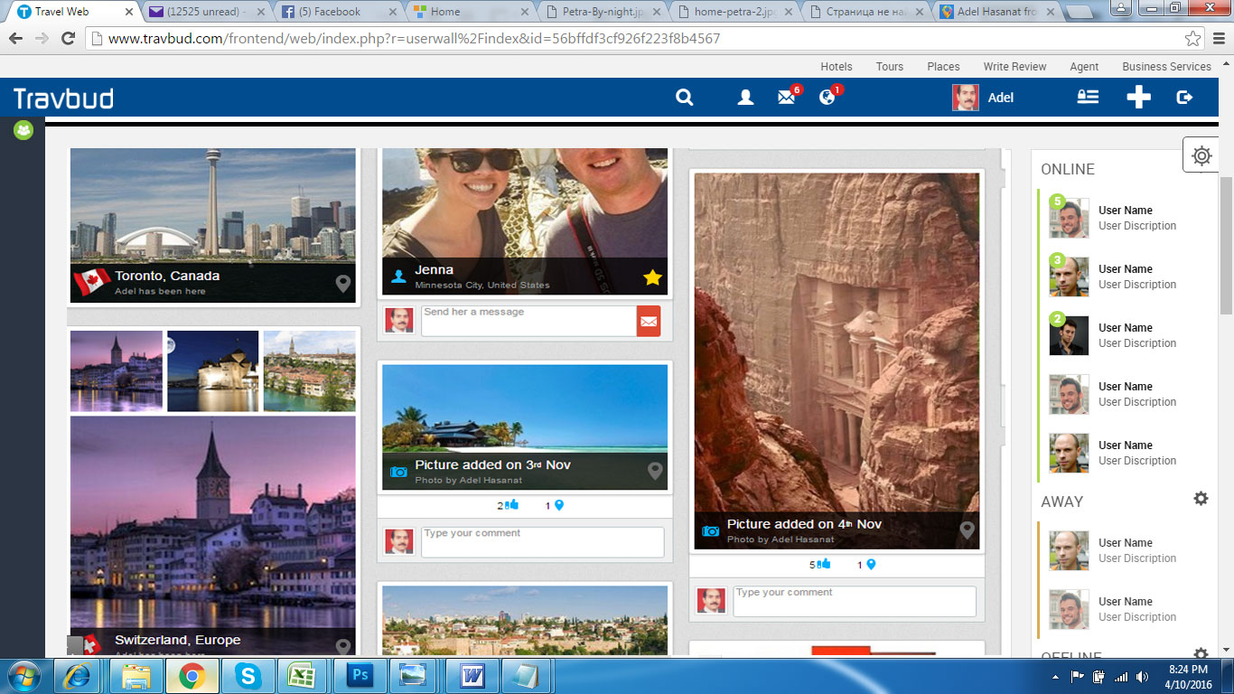

This the Friend output, please list two columns of the friend list when right clicking on the friend icon, please show a menu with Get Notfication that we can see green check mark for ON and red x for OFF. Also Unfriend, Block, Restrict with confirm boxes

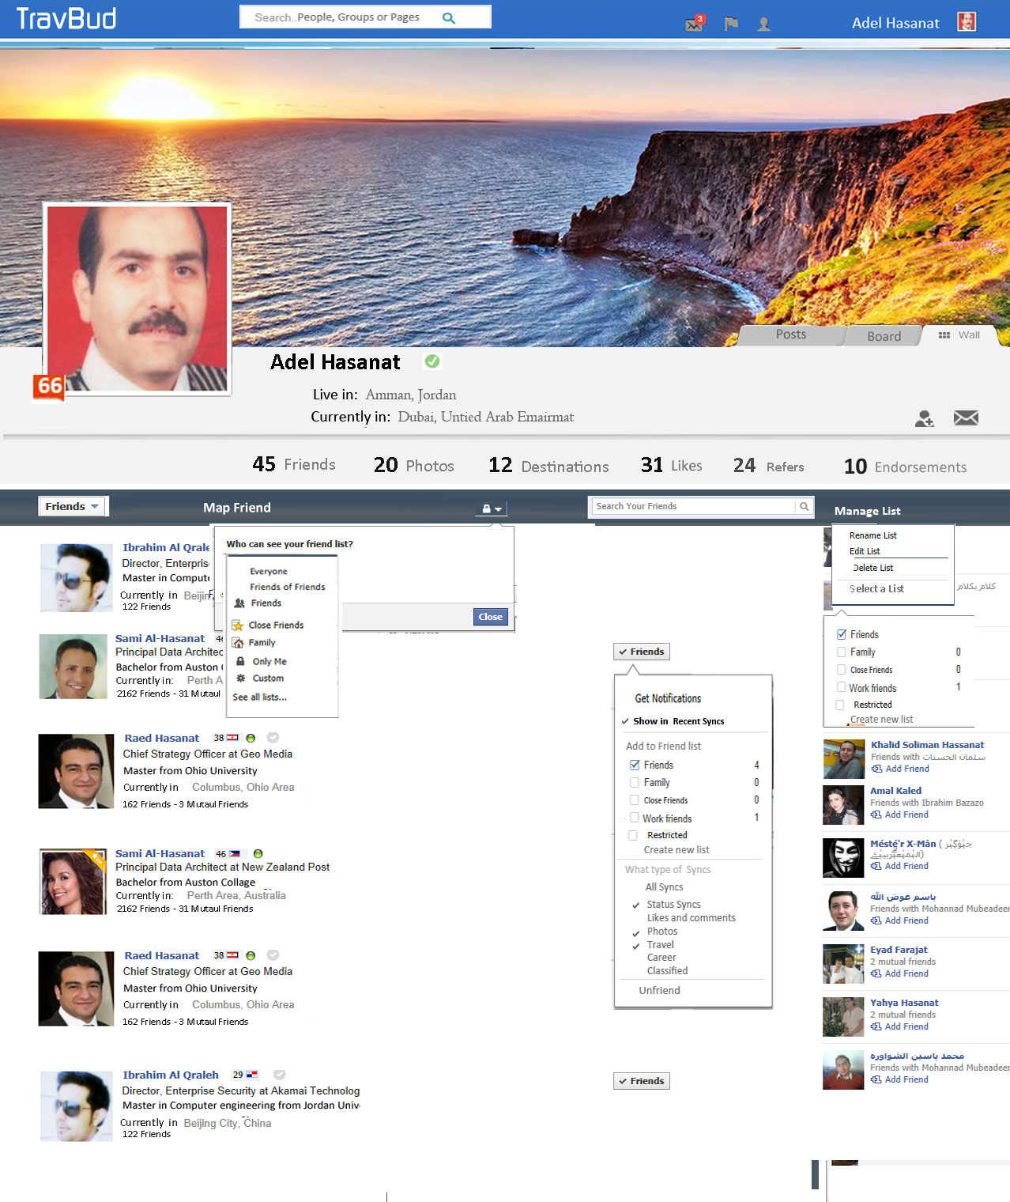

This is the LIKE output screen please follow the screen for desgin
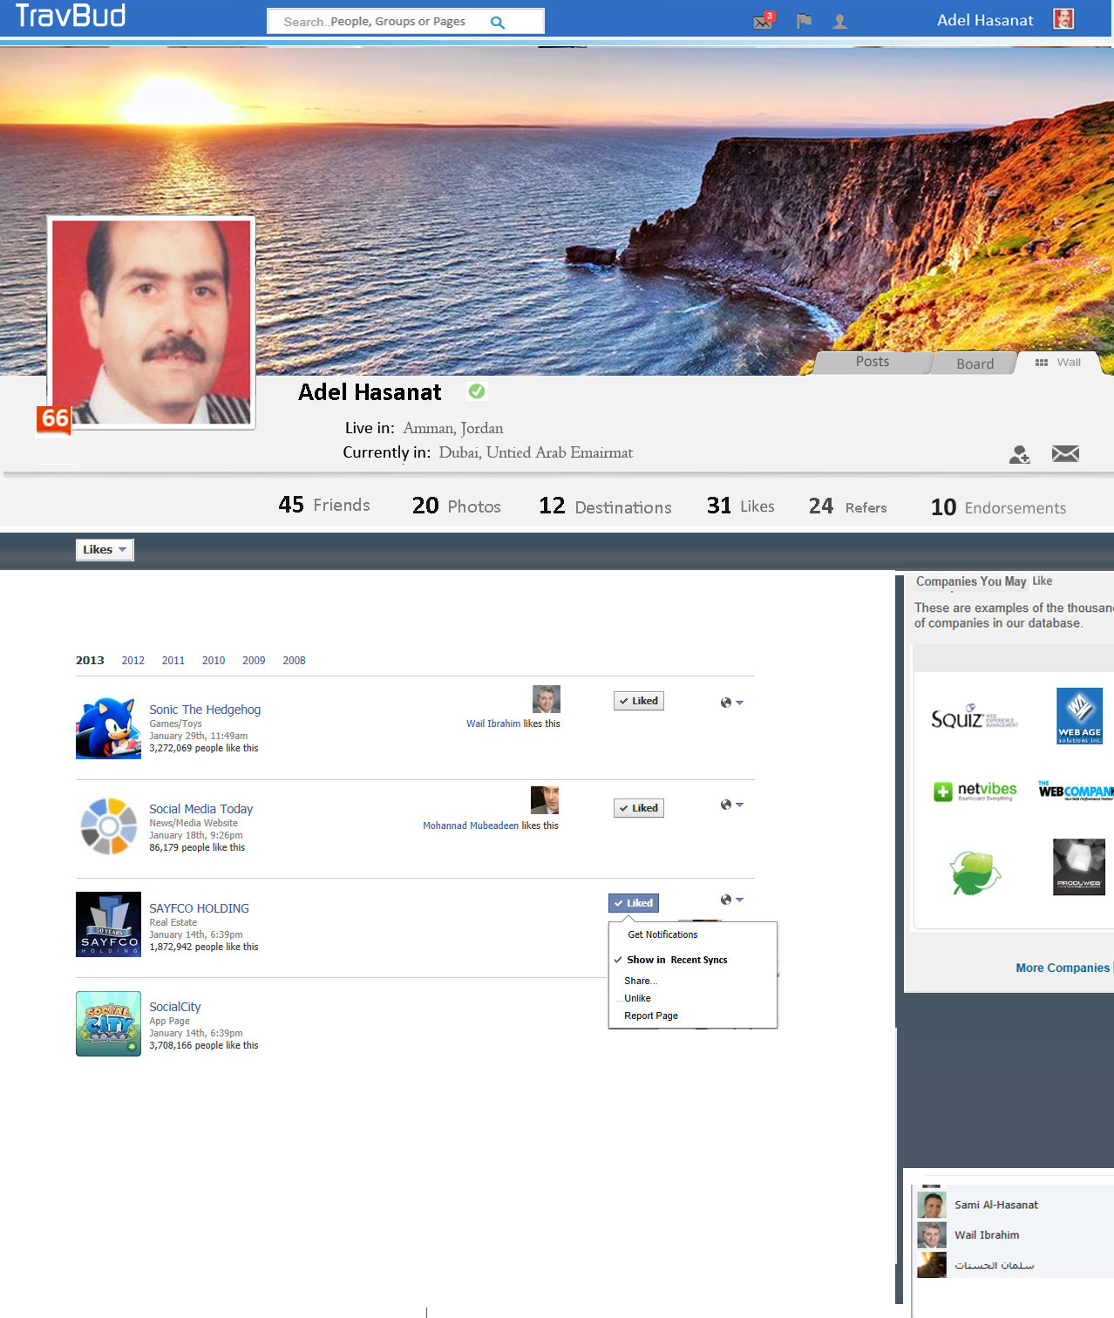

This is the photo screen output, Please the screen for design
